- The UK Budget was a damp squib of small-scale measures that will do little to change the economic or political outlook, in our view. Chancellor Jeremy Hunt implemented a 2p cut in the rates of employees' and self-employed national insurance contributions, along with another freeze in fuel duty.
- These measures will be partially offset by other tax raising measures. The net loosening of policy will provide only a modest boost to our growth forecasts for 2024 and 2025, while subsequent tax rises will drag on GDP further out.
- The NICs cut followed a similar 2p cut in November's Autumn Statement. But the boost to household spending power from lower headline tax rates still only mitigates around half of the drag from the long-running freeze on income tax and NICs allowances and thresholds.
- Though the Chancellor decided against adding to the post-election squeeze on spending, the existing assumptions already looked unfeasibly tight. Today's decisions increase the challenges the next government will face, and we think there's a strong case to overhaul the fiscal rules.
- Today's package reduces the chances of there being another fiscal event before the general election. The Chancellor opted to cut his margin for error against the fiscal rules – his cushion would have been lower still had the forecasts been based on more recent market pricing.
Ahead of the Budget, it was clear that the priority of the government was to deliver a pre-election cut in the headline rate of either income tax or national insurance contributions. Today, the Chancellor achieved this aim, cutting the rate of NICs for employees to 8% from 10%, and for the self-employed to 6% from 8%. These two tax cuts and another fuel duty freeze accounted for almost all of the net £13.9bn (0.5% of GDP) loosening of fiscal policy in 2024-2025. But to keep within his fiscal rules, the Chancellor implemented a series of smaller tax increases – mostly yielding higher revenues only after the coming election – so that by the final year of the forecast horizon, 2028-2029, the net giveaway drops to £6.4bn (0.2% of GDP; Chart 1).
Chart 1: Immediate NICs cut will be partly offset by other tax rises after the election
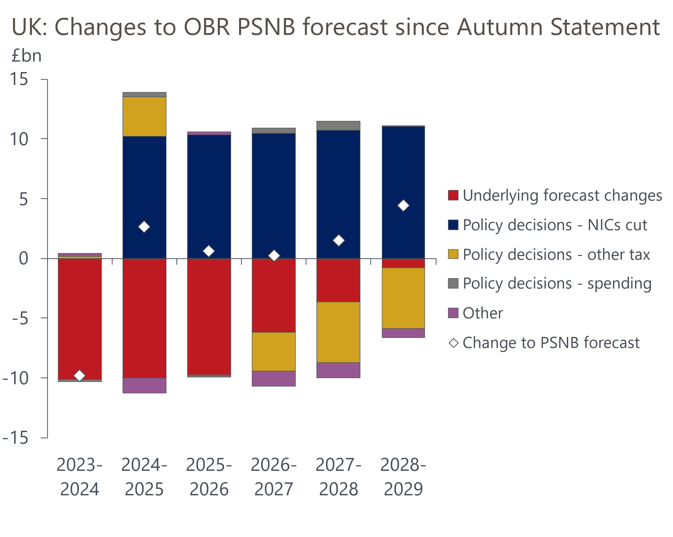
Source: Oxford Economics calculations using forecasts from OBR

To make the sums add up, the Chancellor opted to reduce the headroom against the main net debt rule to just £8.9bn (0.3% of GDP), down from an already low £13bn in November's Autumn Statement. We were surprised that the Office for Budget Responsibility's forecast revisions didn't increase the government's wiggle room. The combination of lower gilt yields and market expectations for Bank Rate, and a lower profile for RPI inflation, meant that the OBR's projection for debt servicing costs in 2028-2029 – the target year for the fiscal rules – is now £14bn lower than at the time of the Autumn Statement.
However, this was broadly offset by a lower forecast for revenues. In his speech, the Chancellor made much of the need to boost GDP without relying on higher immigration, but by incorporating the ONS's recent higher immigration projections, the OBR boosted the potential output forecast. This was offset by a lower assumption for participation, leaving the OBR's forecast for the level of real GDP broadly unchanged. And with the OBR lowering its inflation forecast, largely reflecting recent developments, its projection for nominal GDP, and therefore tax revenues, was lower. This broadly offset the lower debt-interest spending in 2028-2029.

NICs cut will mitigate the damage to growth from frozen thresholds
Relative to our current forecast, the cuts to NICs rates will boost household spending power by around £10bn a year. All else equal, this will likely mean we will nudge up our forecast for GDP growth in 2024 and 2025 when we publish our updated projections as part of our next global update on March 12. However, we're also likely to cut our forecast for growth further out, reflecting the drag from new post-election tax rises, and the fact that there was little in today's measures to warrant any changes in our forecast for potential output.
The NICs cut should also be viewed in the context of the ongoing freeze in most tax thresholds and allowances. The cumulative effect of today's NICs cut, and the similar cut implemented in November's Autumn Statement, will offer a boost to household spending power that is only around half of the drag from frozen income tax and NICs allowances (Chart 2). So changes to the personal tax regime will continue to weigh on economic growth over the next five years.
Chart 2: Cuts to headline NICs rates offset only part of the impact of frozen thresholds and allowances
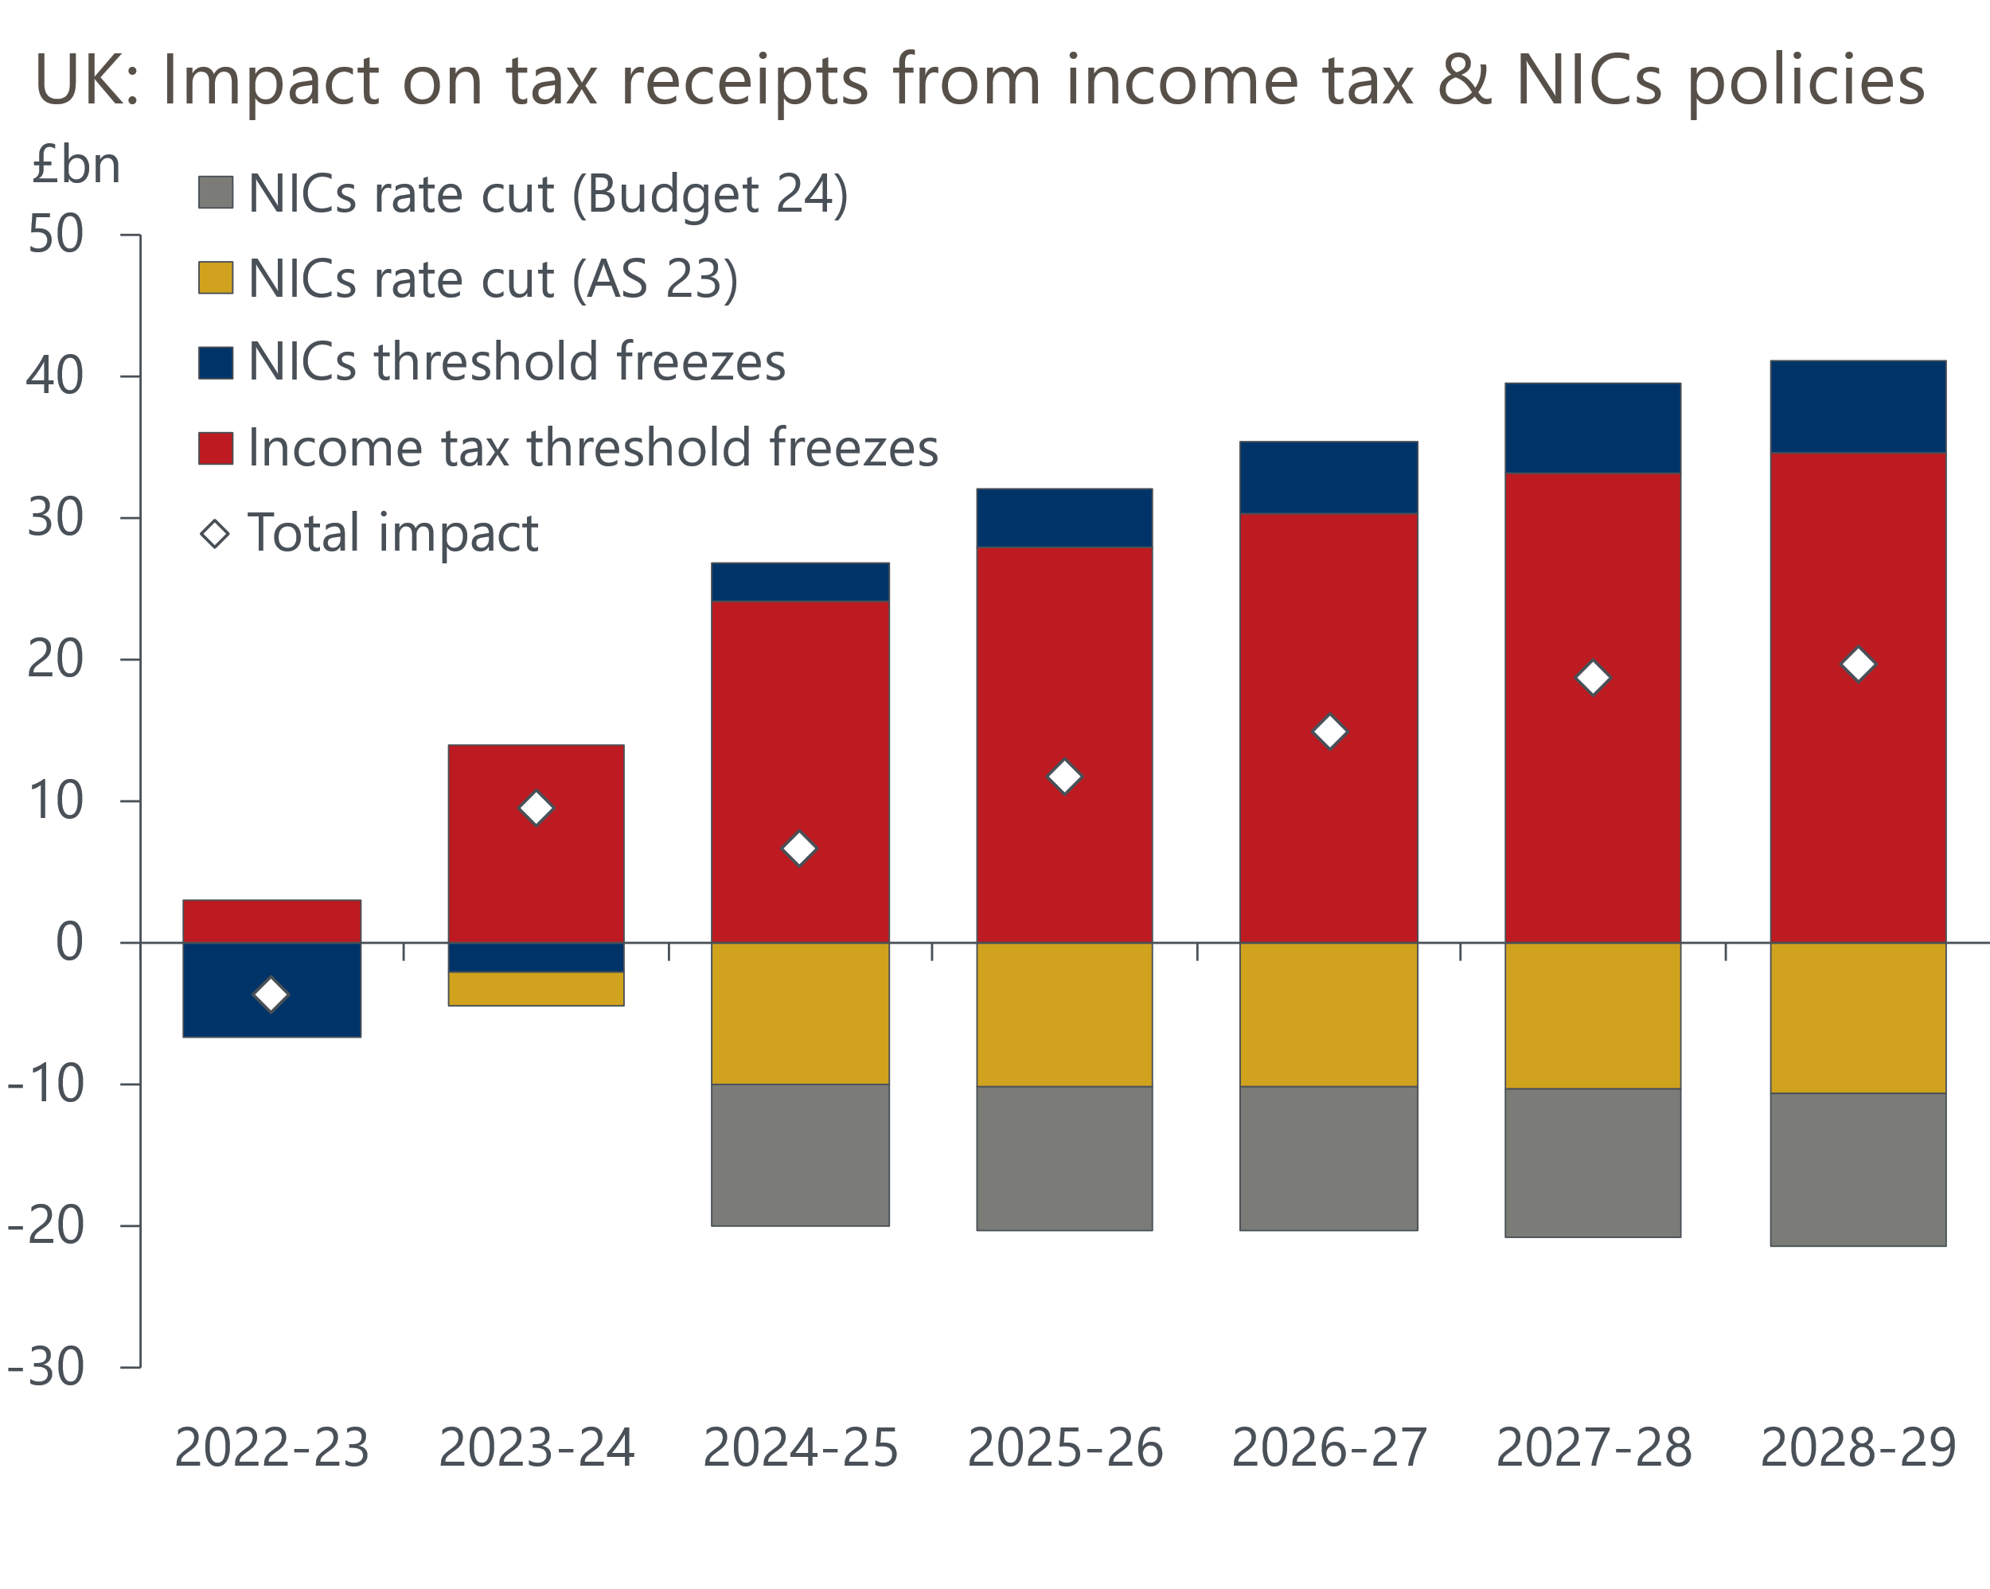
Source: OBR

Hunt opted not to add to the existing spending squeeze
One of the major flaws of the current fiscal rules is that the OBR has to take the government's spending assumptions as given, even if – as is the case at the moment – no supporting detail is offered. This creates an incentive to implement tax cuts that take effect immediately but are notionally paid for by unspecified future spending cuts. The proximity of a general election magnifies this issue and, given the lack of wiggle room, we had been concerned that the Chancellor could have found the opportunity to game the system too tempting to resist.
But to his credit, the Chancellor left the spending assumptions largely unchanged in cash terms. Given the OBR's lower inflation forecast, this meant a small rise in real terms compared to November (Chart 3). Still, this followed a progressive tightening in departmental spending totals from previous fiscal events. And factoring in the rising demands of the National Health Service and defence, the spending totals imply large real terms spending cuts for unprotected government departments.
Chart 3: The government has progressively squeezed future departmental spending
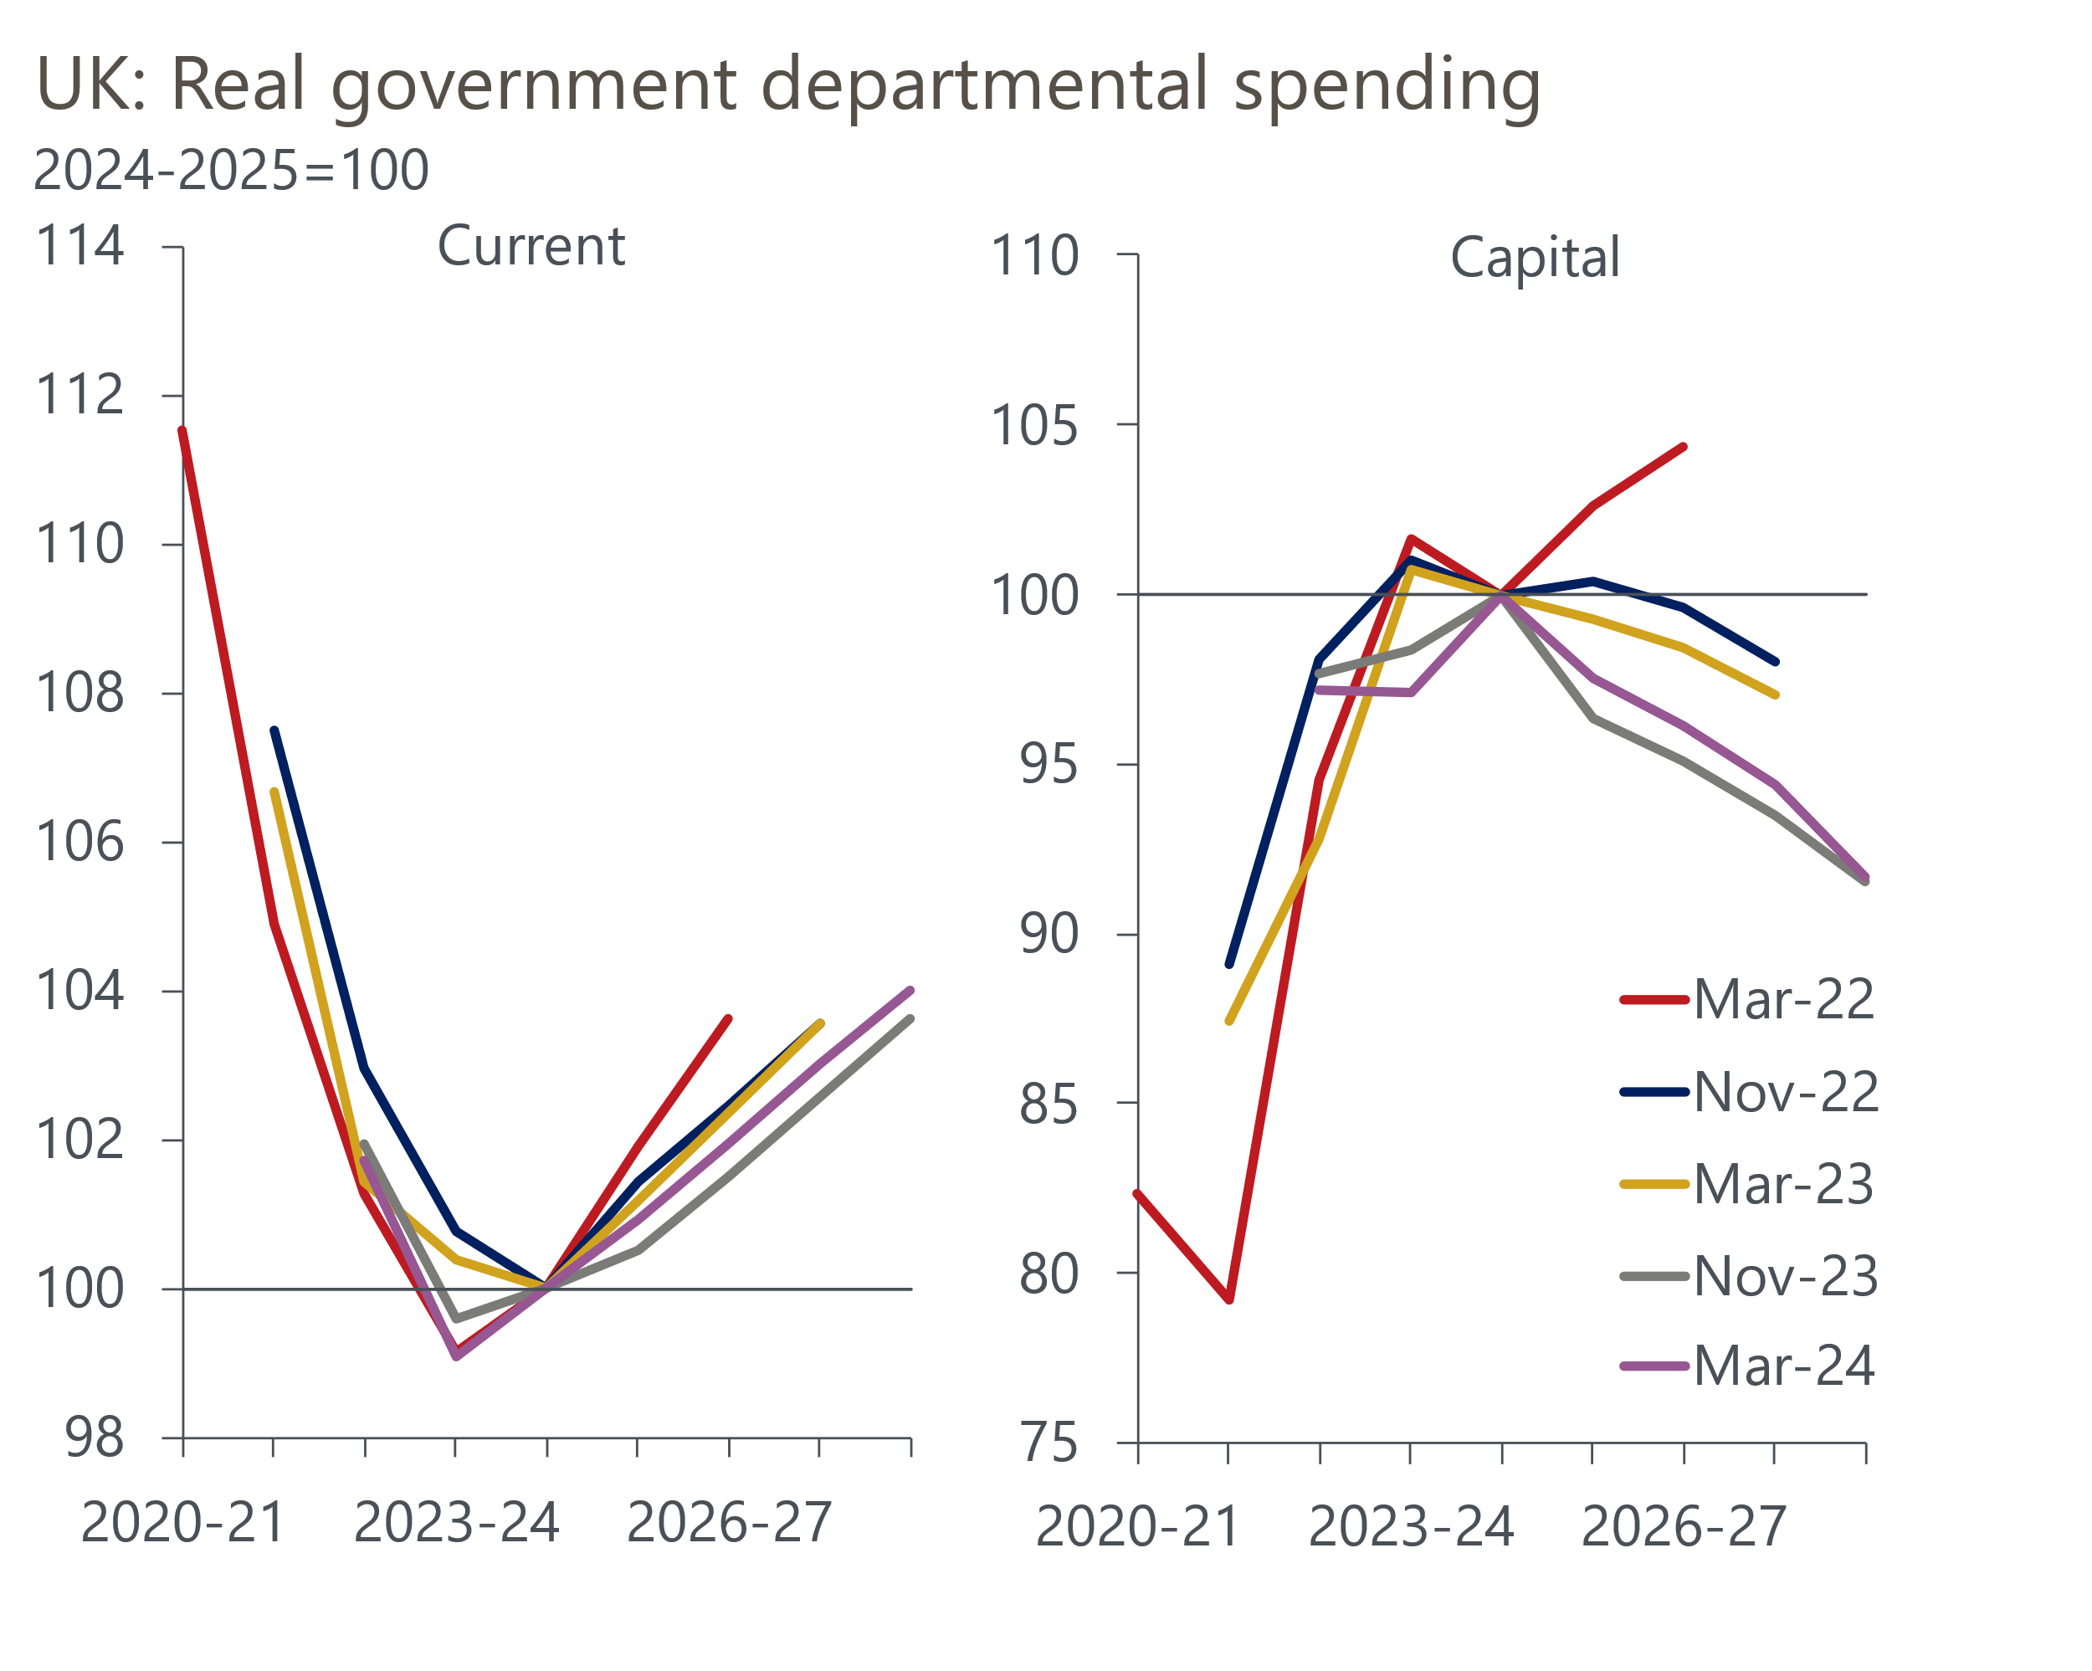
Source: Oxford Economics calculations using forecasts from OBR
The government hopes that boosting public sector productivity will help to square the circle, with the Chancellor announcing the next phase of the Public Sector Productivity Plan will include new investment in NHS IT systems. But this is just the latest in a long line of pledges to boost public sector productivity that have failed to improve the trend. So it's hard to have much confidence that this time will be different.

Budget decisions add to future fiscal policy challenges
The Chancellor's decision to reduce his already-slim margin for error against the main fiscal rule to fund another NICs cut signals this is likely to have been the final fiscal event before the general election. The fiscal arithmetic could easily go against him next time. The OBR used financial market pricing for the 10 days to January 23 to underpin its forecast. But market pricing has moved a lot since then. Indeed, if the OBR were using prices from the 10 days up to yesterday, then its projection for debt-interest costs in the target year would be £2bn higher, removing a quarter of the headroom against the debt target (Chart 4).
Chart 4: Market pricing has moved unfavourably since the OBR locked its assumptions
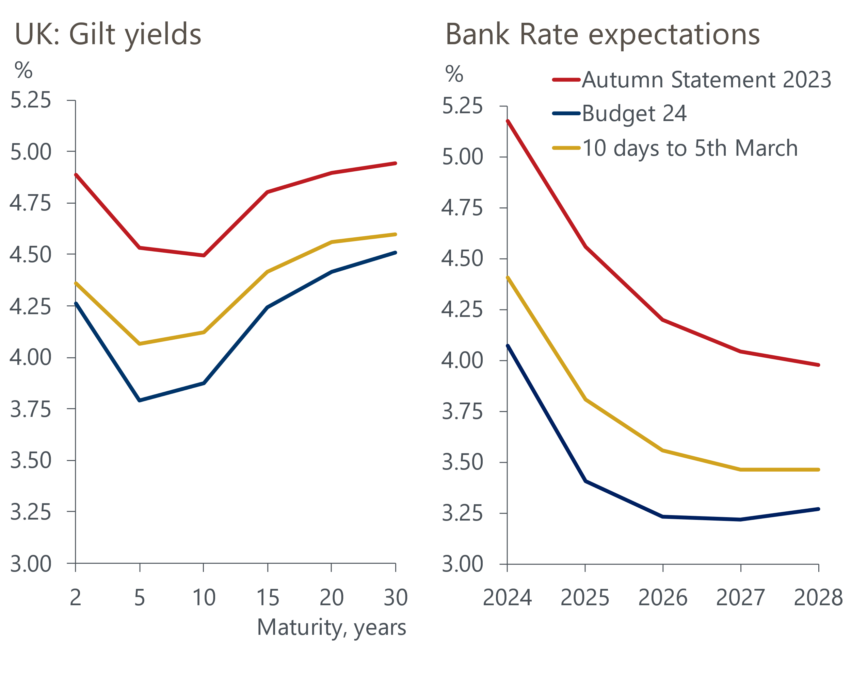
Source: Haver Analytics
Given the risks are skewed towards rate cuts coming later and more slowly, and that the OBR's medium-term growth forecast is more optimistic than the consensus, the Chancellor might find that a net tightening of policy would be needed at the next fiscal event to comply with the fiscal rules.
If this is the final fiscal event of the current parliament, then today's decisions add to the challenges the next government will face, regardless of which party wins the election. Assuming the fiscal rules remain unchanged, before making any policy plans of its own the next government will need to implement the following measures inherited from the current administration:
- Keep most tax thresholds and allowances frozen until 2027-2028;
- Allow the 'temporary' fuel duty cut to expire (it was implemented in March 2022 and was due to last one year; it has now been extended twice, with the latest extension running to March 2025) and resume the indexation of fuel duty (it hasn't been indexed since 2011, despite the government continually telling the OBR it should assume indexation will resume the following year);
- Implement the spending restraint that the current government has told the OBR to base its forecasts on.
As we argued in a recent report, this inheritance would severely limit the room for manoeuvre of a potential Labour government, particularly given that it has indicated it would adopt similar fiscal rules to the current administration.
But we think there's a better approach to this problem. We will publish a report next week that will set out our proposals for improving the fiscal rules, and show the results of our modelling that quantifies the impact that a new framework could have on growth prospects and key fiscal metrics.

